1. m = -3, b = 0
m = 0, b = 0
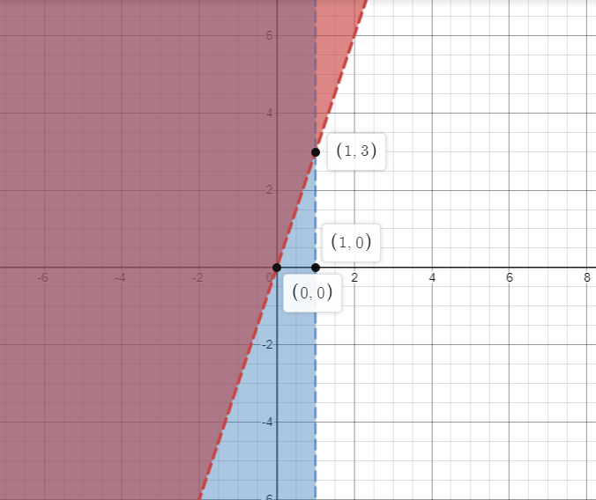

2.
m = -1, b = 3
m = -1, b =5
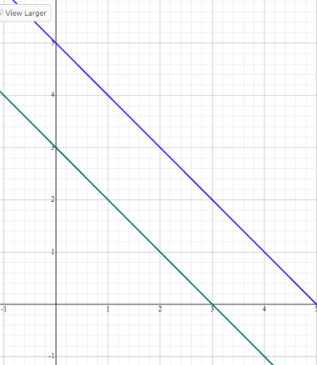

3.
m= 0 b=3,
m=0, b= -6
Solution set x=-6, y=3
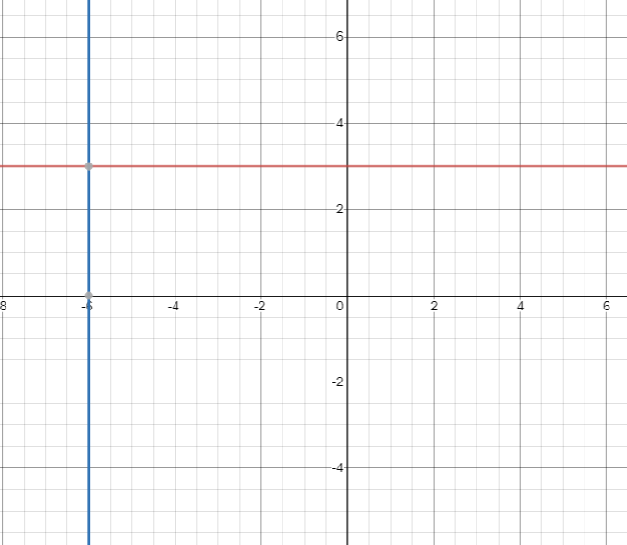

4.
